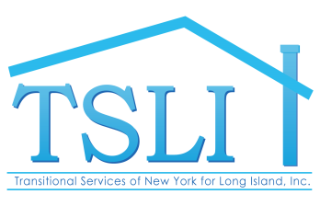
840 Suffolk Avenue Brentwood, New York 11717-4412
631.231.3619 Fax 631.231.4754
www.tsli-hhb.org

TSLI PATHWAYS  A Mental Health Program  TSLI SUMMIT  A Permanent Housing Program  TSLI SEP  An Employment Program  HHB SHELTERS  A Homeless Housing Program  HHB PHP  A Permanent Housing Program  HHB PREVENTION  A Homeless Prevention Program  BOARD OF DIRECTORS  HONORARY CHAIRPERSON  MAX SCHNEIER, J.D.  (1916-2002)  FRANCIS X. McCAUGHEY  (1942-2012)  TSLI PRESIDENT  MARCIA K. FIELD, ESQ  HHB PRESIDENT  RICHARD J. BONANNO, M.  MEMBERS  REBECCA BONANNO Ph.D.  MARY BETH GRIFFIN  GARY LOMBARDI  KAY POSILLICO, LCSW  JON RUISS, JR., CPA/ESQ.  COMMUNITY ADVISORY BOARD  JAN ASHLEY  STEVEN CIANCIABELLA  JANET DUFFY  WILLIAM HANDWERKER  DANIEL LIBERTY  PATRICIA LIOTTA  THOMAS McATEER  JOSEPH SANTACROCE  CHIEF EXECUTIVE OFFICER  BRUNO J. LASPINA, ESQ.  CHIEF OPERATING OFFICER  LINDSAY MEYER  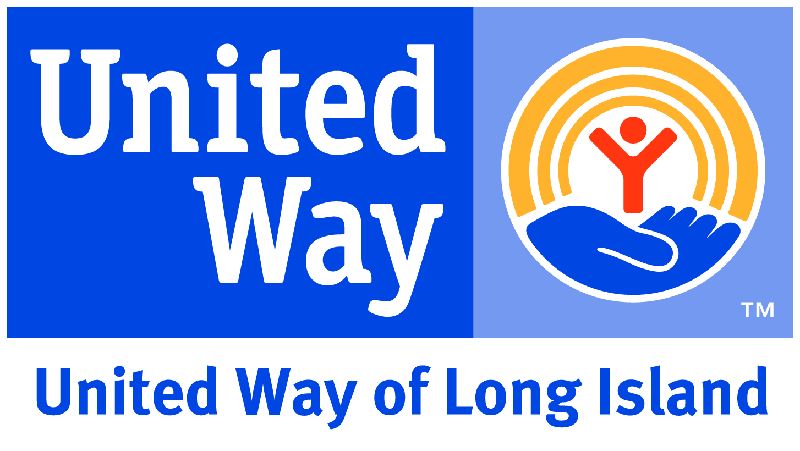  Participating Agency  A Voluntary Not-For-Profit Agency | September 12, 2022  Dear Friend,  First and foremost, allow me to extend to you and your loved ones our wishes that this letter finds you all safe and well in the face of these challenging times.  As many of you know our annual Human Services Award event is, as always, scheduled for the Thursday prior to Thanksgiving, which this year would have been November 17, 2022.  In spite of the fact that New York State appears to be in the forefront of this nation’s response to the threat and danger presented by the COVID-19 virus, we in New York are not immunized to the hazard presented by the different and ever-changing variants of the virus.  We continue to take every precaution including incentivizing the COVID-19 vaccinations for our residents and staff as well as enforcing mask wearing to protect those who live and work in our programs.  Despite our strict adherence to best practices, mutations of the COVID-19 virus compel us to err on the side of caution. The exhaustion that each of us experience in the face of this seemingly inexhaustible adversary is captured in what is now a familiar refrain “I’ve had it with this COVID.” Unfortunately, COVID and its myriad mutations has not had it with us.  As such, the Board of Directors of TSLI and HHB have determined that this year’s, in person, Annual Human Services Dinner, as it was last year, be cancelled.  We have conferred with this year’s prospective honoree, Chris Brady, Senior Vice President of HUB International and he agrees with this decision. Simply stated, we have no interest in exposing our loyal supporters and friends to a COVID spreader event.  Of course, as you may well imagine, one of the many collateral challenges our Agency’s programs have faced throughout the pandemic are the additional costs associated with protecting our residents and staff as well as maintaining our residences. In addition, along with the challenges of a work-force shortage, many of our residents are experiencing increased difficulty in the management of the symptoms related to their mental illness. Residents continue to be prevented from attending their regular clinic appointments and meeting face-to-face with their community-based supports. As such, despite the challenge of short staffing, we are working even more diligently to effectively address increased residents’ needs.  Although we are cancelling this year’s Human Services Award event the need for your continued financial support, as you can imagine, is even more critical now than in the past. We are all saddened and alarmed at the human toll this pernicious silent enemy has taken on those we know and love. Unfortunately, we have experienced this loss first-hand within our Agency and in our personal lives. Those lost will be remembered, while the residents and their families can rest assured our work goes on despite the augmented demands on our front-line workers who serve those residents in our care.  With all this in mind, we ask that you continue to support our programs in this time of great need and financial challenge. Be safe and well.  Sincerely,  Bruno J. LaSpina  Bruno J. LaSpina, CEO

